IICT REPORT

Samsung Galaxy Gear VR

BY

SYED WALI

MUHAMMAD SIRAJ

Muhammad Talha sarfaraz

Contents

**I.** **INTRODUCTION** 0

**II.** **TYPES VIRTUAL REALITY** 1

**A.** **Oculus Rift** 1

**B.** **Augmented reality** 1

**C.** **Oculus Gear VR** 2

**III.** **WORKING** 2

**A.** **OCULUS RIFT** 2

**1.** **SOFTWARE** 2

**2.** **HARDWARE** 2

**B. Augmented reality** 2

**1. SOFTWARE** 2

**2.** **HARDWARE** 3

**C. OCULUS GEAR VR** 3

**1. SOFTWARE** 3

**2.** **HARDWARE** 3

**IV.** **Conclusion** 3

**V.** **References** 3

**Dedication**

Well, this project is all about virtual world/reality. In which we can image and experience to different part of beautiful places, I want to dedicate it to my group mates without them its was not possible as well as this thesis is dedicated to my class teacher, who taught me extraordinary that the best kind of knowledge to have is that which is learned for its own sake. It is also dedicated to my elder brother, who taught me that even the largest task can be accomplished if you have believe to do it.

## **INTRODUCTION**

Well, the summary of this topic is that Samsung’s gear VR (virtual reality) is one of the most impressive and easy to use headsets available right now, The company also partnered with oculus to develop the Gear VR. In the early time it was too difficult to make it. Some company tried their best but all of them failed.

Somehow, they reached at [3D displays](https://en.wikipedia.org/wiki/3D_display). Used stereoscopic method to convey images. It was first invented by [Sir Charles Wheatstone](https://en.wikipedia.org/wiki/Sir_Charles_Wheatstone) in 1838, and improved by Sir [David Brewster](https://en.wikipedia.org/wiki/David_Brewster) who made the first portable 3D viewing device. But it was too expensive. Later on an idea came on Palmer Lackey’s minds about virtual reality by using HMD (Head Mounted Display) and finally the Samsung Gear VR consumer edition was released in November 2015. And probably it was one of the amazing technology around the world the rapid progress of technological innovation, the virtual and augmented reality market is grown to tens of billions of dollars in the next decade, Man has been trying to create visually immersive experiences for hundreds of years. “Many [science fiction](https://en.wikipedia.org/wiki/Science_fiction) books and films have imagined characters being "trapped in virtual reality" or entering into virtual reality. From the past until now mobile phones has completely changed the people’s life style it has got alots of features A smartphone is in essence a web-connected mobile phone. It will have the ability to send and receive email, browse the web, and install apps - small software programs designed for use on a smartphone or tablet but with the passage of time it was getting older and people got fed up by using it. may be it could not invent any new technologies which can amaze people absorption. Although, on that time people used to amaze with 3d technology. But it was not good enough to catch people interest. All companies were busy to solve this problem. they kept on trying to get fixed it. And finally it worked for them.

in January 2005, Samsung had obtained a HMD (Head Mounted Display) . This was one of the first ideas of using a mobile phone as the display for a HMD. However, mobile phone technology at the time were limited but the degree of quality and performance possible. Samsung continued to research VR and HMD internally. And finally the Samsung Gear VR consumer edition was released with the help of oculus company in November 2015. Oculus is an American technology company founded by Palmer Luckey. It specializes in virtual reality hardware and software products. In this way they invented 360 gear vr. In this whole extent they had to face lots of technology challenges. Like Compensating for the Magnifying Lens, Display Resolution, Field of View are top of the list. Around the age of 15, Palmer Luckey started to fall in love with the concept of virtual reality. By that day, he attended classes at the local community college. By night, and now he is the founder of oculus company. Throughout the late 80s and 90s, dozens of companies tried to turn VR headsets into commercial success. All of them failed hard. Some were too expensive; most just didn’t work worth a damn. All of them were far too ahead of their time. In April 2012, Palmer Luckey announced a virtual reality headset designed for video gaming, in August company allowed to virtual reality headsets available to developers. The campaign proved successful and raised $2.4 Million, ten times the original goal. The consumer product was released on March 28, 2016 with an all-new design incorporating specialized VR displays, positional audio, and infrared tracking system. The company also partnered with Samsung to develop the Samsung Gear VR in November 2015, for the Samsung Galaxy models. after the success of the, in-development, Rift

## **TYPES VIRTUAL REALITY**

## **Oculus Rift**

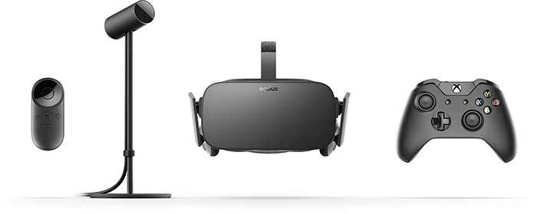Oculus Rift is a VIRTUAL REALITY HEADSET developed and manufactured by Oculus VR, released on March 28, 2016.It works with your gaming desktop or laptop. Rift accomplishes using a pair of screens that displays two images side by side, one for each eye. A set of lenses is placed on top of the panels, focusing and reshaping the picture for each eye, and creating a 3D image. The goggles have embedded sensors that monitor the wearer's head motions and adjust the image accordingly.

## **Augmented reality**

Augmented reality (AR) is a live direct or indirect view of a physical, real-world environment whose elements are augmented (or supplemented) by computer-generated sensory input such as sound, video, graphics or GPS data. It is related to a more general concept called mediated reality, in which a view of reality is modified (possibly even diminished rather than augmented) by a computer. As a result, the technology functions by enhancing one’s current perception of reality. By contrast, virtual reality replaces the real world with a simulated one. Augmentation is conventionally in real time and in semantic context with environmental elements, such as sports scores on TV during a match.

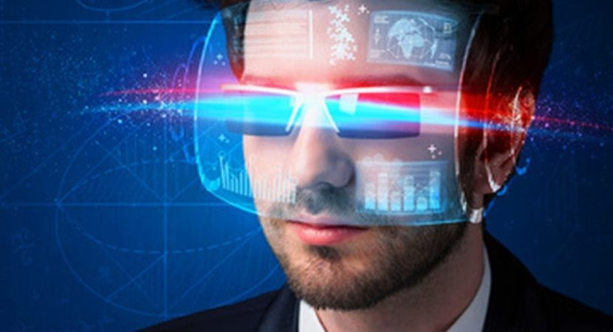

## **Oculus Gear VR**

The stand for of VR is virtual reality. It’s a kind of computer technologies that use software to generate realistic images, in this technology you can imagine 360 realistic video, images, and games. You may sense and experience world realistic thing by the help of 360 videos.

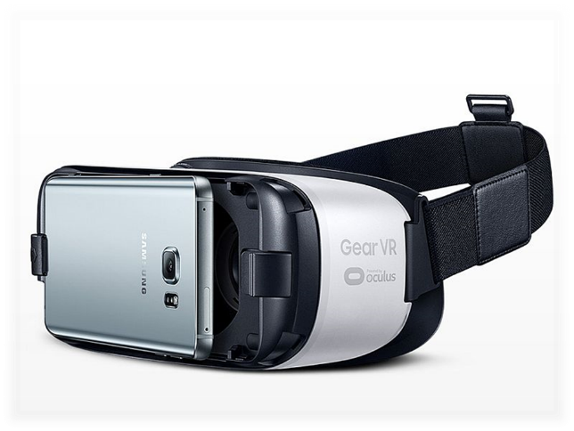

## **WORKING**

## **OCULUS RIFT**

## **SOFTWARE**

SDK Content for the Rift is developed using the Oculus PC SDK. It handles the various aspects of making VR content such as the optical distortion and advanced rendering techniques. Runtime/Drivers: Oculus drivers and a runtime service are used to allow applications to output directly to the Rift,

## **HARDWARE**

The Oculus Rift headset uses an OLED panel for each eye, each having a resolution of 1080×1200. These panels have a refresh rate of 90Hz.It uses a lenses that allow a wide view for a user. The separation of the lenses is adjustable by a dial on the bottom of the device. Constellation: Constellation is the headset's positional tracking system, used to track the position of the user's head as well as other VR devices, Controllers: A motion controller system known as Oculus Touch Controllers each containing a joystick, buttons, and two triggers - one for grabbing and one for shooting or firing. The controllers are fully tracked in 3D space by the Constellation system, so they may be represented in the virtual environment.

**B. Augmented reality**

## **1. SOFTWARE**

A key measure of AR systems is how realistically they integrate augmentations with the real world. The software must derive real world coordinates, independent from the camera, from camera images. That process is called image registration which uses different methods of computer vision, mostly related to video tracking. Many computer vision methods of augmented reality are inherited from visual odometry. Augmented Reality Markup Language (ARML) is a data standard developed within the Open Geospatial Consortium (OGC),which consists of XML grammar to describe the location and appearance of virtual objects in the scene, as well as ECMAScript bindings to allow dynamic access to properties of virtual objects. To enable rapid development of Augmented Reality Applications, some software development kits (SDKs) have emerged

## **HARDWARE**

Hardware components for augmented reality are: processor, display, sensors and input devices. Modern mobile computing devices like smartphones and tablet computers contain these elements which often include a camera and MEMS sensors such as accelerometer, GPS, and solid state compass, making them suitable AR platforms.

## **C. OCULUS GEAR VR**

## **1. SOFTWARE**

The Samsung Gear VR is a mobile virtual reality headset developed by Samsung Electronics. in collaboration with Oculus. The operating system which use in VR is “oculus” Oculus Home is the main facility to download and use content on the Samsung Gear VR. Oculus Home is also the main line for software distribution on the Gear VR.

## **HARDWARE**

The hardware of gear VR is the headset's display and processor, while the Gear VR unit itself acts as the controller, which contains the high field of view, as well as a custom inertial measurement unit, or IMU, for rotational tracking, which connects to the smartphone via micro-USB. The Gear VR headset also includes a touchpad and back button on the side, as well as a proximity sensor to detect when the headset is on Oculus Home is the main facility to download and use content on the Samsung Gear VR. Oculus Home is also the main line for **software distribution on the Gear VR.**

## **Conclusion**

The conclusion of this report is that in this new era technologies has changed the human life completely. Virtual reality is one of that technology headsets to generate the realistic images, sounds and other sensations that replicate a real environment or create an imaginary setting.

Its surprise for me. That I can see beautiful places in virtual world and experience them quiet easily. It can happen because of gear vr and it different types respectively.

## **References**

1. <https://en.wikipedia.org/wiki/Augmented_reality#References>
2. <http://computer.howstuffworks.com/augmented-reality.htm>
3. <https://en.wikipedia.org/wiki/Virtual_reality>
4. <https://en.wikipedia.org/wiki/Oculus_Rift>
5. <https://en.wikipedia.org/wiki/Samsung_Gear_VR>